**Hamna Qasim 55194**

**Web App Development Lab # 7**

**Tasks**

Task1:

<!DOCTYPE html>

<html lang="en">

<head>

    <meta charset="UTF-8">

    <meta name="viewport" content="width=device-width, initial-scale=1.0">

    <title>Document</title>

</head>

<body>

    <h1>Web App Devlopment</h1>

    <script src="task1.js"></script>

</body>

</html>

heading = document.getElementsByTagName("h1")[0];

const name="Hamna Qasim";

const no="07613";

heading.innerText += " - " + name + " " + no ;

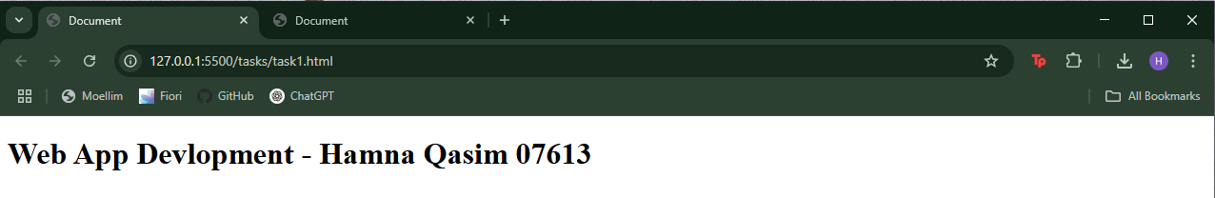

Task2:

<!DOCTYPE html>

<html lang="en">

<head>

    <meta charset="UTF-8">

    <meta name="viewport" content="width=device-width, initial-scale=1.0">

    <title>Document</title>

</head>

<body>

    <div class="Container"></div>

    <div class="Container"></div>

    <div class="Container"></div>

    <script src="task2.js"></script>

</body>

</html>

const containers = document.querySelectorAll('.Container');

let no=0;

containers.forEach((container, no) => {

    container.textContent = `This container is number ${no + 1}`;

});

